Lab - Using Wireshark to Examine TCP and UDP Captures

# Topology - Part 1 (FTP)

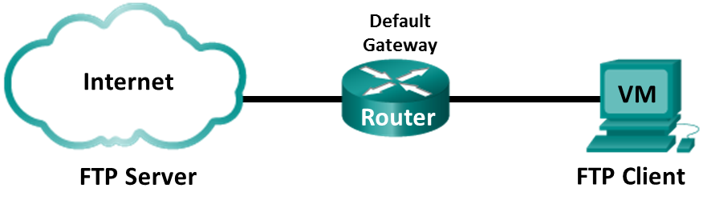

Part 1 will highlight a TCP capture of an FTP session. This topology consists of the CyberOps Workstation VM with internet access.

# Mininet Topology - Part 2 (TFTP)

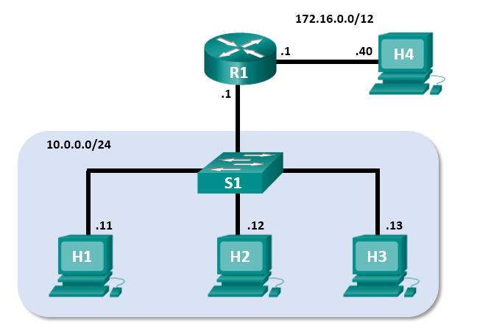

# Objectives

Part 1: Identify TCP Header Fields and Operation Using a Wireshark FTP Session Capture

Part 2: Identify UDP Header Fields and Operation Using a Wireshark TFTP Session Capture

# Background / Scenario

Two protocols in the TCP/IP transport layer are TCP (defined in RFC 761) and UDP (defined in RFC 768). Both protocols support upper-layer protocol communication. For example, TCP is used to provide transport layer support for the HyperText Transfer Protocol (HTTP) and FTP protocols, among others. UDP provides transport layer support for the Domain Name System (DNS) and TFTP, among others.

In Part 1 of this lab, you will use the Wireshark open source tool to capture and analyze TCP protocol header fields for FTP file transfers between the host computer and an anonymous FTP server. The terminal command line is used to connect to an anonymous FTP server and download a file. In Part 2 of this lab, you will use Wireshark to capture and analyze UDP header fields for TFTP file transfers between two Mininet host computers.

# Required Resources

* CyberOps Workstation VM
* Internet access

# Instructions

## Identify TCP Header Fields and Operation Using a Wireshark FTP Session Capture

In Part 1, you use Wireshark to capture an FTP session and inspect TCP header fields.

### Start a Wireshark capture.

* + - 1. Start and log into the CyberOps Workstation VM. Open a terminal window and start Wireshark. The ampersand (&) sends the process to the background and allows you to continue to work in the same terminal.

[analyst@secOps ~]$ **wireshark &**

* + - 1. Start a Wireshark capture for the **enp0s3** interface.
      2. Open another terminal window to access an external ftp site. Enter **ftp ftp.cdc.gov** at the prompt. Log into the FTP site for Centers for Disease Control and Prevention (CDC) with user **anonymous** and no password.

[analyst@secOps ~]$ **ftp ftp.cdc.gov**

Connected to ftp.cdc.gov.

220 Microsoft FTP Service

Name (ftp.cdc.gov:analyst): **anonymous**

331 Anonymous access allowed, send identity (e-mail name) as password.

Password:

230 User logged in.

Remote system type is Windows_NT.

ftp>

### Download the Readme file.

* + - 1. Locate and download the Readme file by entering the **ls** command to list the files.

ftp> **ls**

200 PORT command successful.

125 Data connection already open; Transfer starting.

-rwxrwxrwx 1 owner group 128 May 9 1995 .change.dir

-rwxrwxrwx 1 owner group 107 May 9 1995 .message

drwxrwxrwx 1 owner group 0 Feb 2 11:21 pub

-rwxrwxrwx 1 owner group 1428 May 13 1999 Readme

-rwxrwxrwx 1 owner group 383 May 13 1999 Siteinfo

-rwxrwxrwx 1 owner group 0 May 17 2005 up.htm

drwxrwxrwx 1 owner group 0 May 20 2010 w3c

-rwxrwxrwx 1 owner group 202 Sep 22 1998 welcome.msg

226 Transfer complete.

**Note**: You may receive the following messages:

421 Service not available, remote server has closed connection

ftp: No control connection for command

501 Server cannot access argument

500 command not understood

ftp: bind: Address already in use

If this happens, then the FTP server is currently down. However, you can proceed with the rest of the lab analyzing those packets that you were able to capture and reading along for packets you did not capture. You can also return to the lab later to see if the FTP server is back up.

* + - 1. Enter the command **get Readme** to download the file. When the download is complete, enter the command **quit** to exit. (**Note**: If you are unable to download the file, you can proceed with the rest of the lab.)

ftp> **get Readme**

200 PORT command successful.

125 Data connection already open; Transfer starting.

WARNING! 36 bare linefeeds received in ASCII mode

File may not have transferred correctly.

226 Transfer complete.

1428 bytes received in 0.056 seconds (24.9 kbytes/s)

* + - 1. After the transfer is complete, enter **quit** to exit ftp.

### Stop the Wireshark capture.

### View the Wireshark main window.

Wireshark captured many packets during the FTP session to ftp.cdc.gov. To limit the amount of data for analysis, apply the filter **tcp and ip.addr == 198.246.117.106** and click **Apply**.

**Note**: The IP address, 198.246.117.106, is the address for [ftp.cdc.gov](ftp://ftp.cdc.gov) at the time this lab was created. The IP address may be different for you. If so, look for the first TCP packet that started the 3-way handshake with [ftp.cdc.gov](ftp://ftp.cdc.gov). The destination IP address is the IP address you should use for your filter.

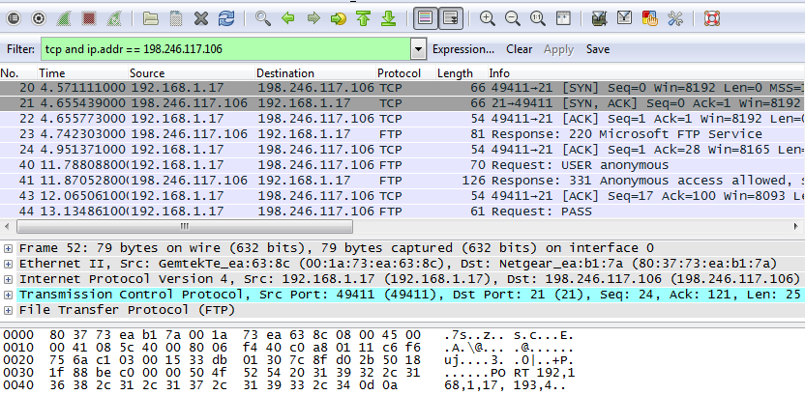

**Note**:Your Wireshark interface may look slightly different than the above image.

### Analyze the TCP fields.

After the TCP filter has been applied, the first three packets (top section) display the sequence of [SYN], [SYN, ACK], and [ACK] which is the TCP three-way handshake.

Screen shot of the three packets displaying the TCP three-way handshake

TCP is routinely used during a session to control datagram delivery, verify datagram arrival, and manage window size. For each data exchange between the FTP client and FTP server, a new TCP session is started. At the conclusion of the data transfer, the TCP session is closed. When the FTP session is finished, TCP performs an orderly shutdown and termination.

In Wireshark, detailed TCP information is available in the packet details pane (middle section). Highlight the first TCP datagram from the host computer, and expand portions of the TCP datagram, as shown below.

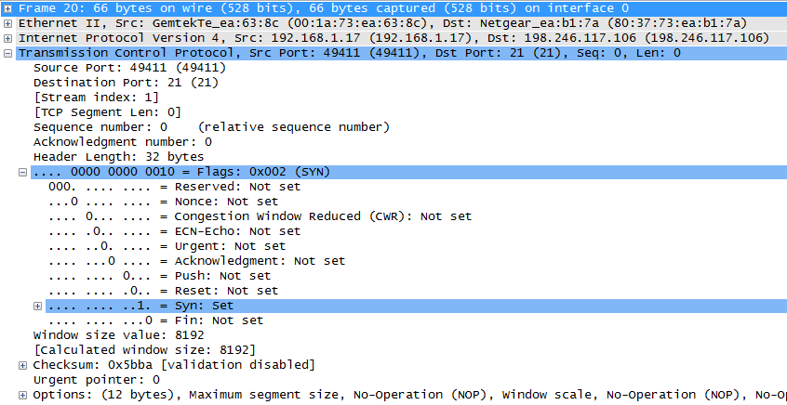

The expanded TCP datagram appears similar to the packet detail pane, as shown below.

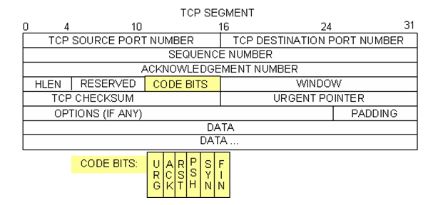

The image above is a TCP datagram diagram. An explanation of each field is provided for reference:

* The **TCP source port number** belongs to the TCP session host that opened a connection. The value is normally a random value above 1,023.
* The **TCP destination port number** is used to identify the upper layer protocol or application on the remote site. The values in the range 0–1,023 represent the “well-known ports” and are associated with popular services and applications (as described in RFC 1700), such as Telnet, FTP, and HTTP. The combination of the source IP address, source port, destination IP address, and destination port uniquely identifies the session to the sender and receiver.

**Note**: In the Wireshark capture above, the destination port is 21, which is FTP. FTP servers listen on port 21 for FTP client connections.

* The **Sequence number** specifies the number of the last octet in a segment.
* The **Acknowledgment number** specifies the next octet expected by the receiver.
* The **Code bits** have a special meaning in session management and in the treatment of segments. Among interesting values are:
  1. **ACK** — Acknowledgment of a segment receipt.
  2. **SYN** — Synchronize, only set when a new TCP session is negotiated during the TCP three-way handshake.
  3. **FIN** — Finish, the request to close the TCP session.
* The **Window size** is the value of the sliding window. It determines how many octets can be sent before waiting for an acknowledgment.
* The **Urgent pointer** is only used with an Urgent (URG) flag when the sender needs to send urgent data to the receiver.
* The **Options** has only one option currently, and it is defined as the maximum TCP segment size (optional value).

Using the Wireshark capture of the first TCP session startup (SYN bit set to 1), fill in information about the TCP header. Some fields may not apply to this packet.

From the VM to CDC server (only the SYN bit is set to 1):

| Description | Wireshark Results |
| --- | --- |
| Source IP address | blank |
| Destination IP address | blank |
| Source port number | blank |
| Destination port number | blank |
| Sequence number | blank |
| Acknowledgment number | blank |
| Header length | blank |
| Window size | blank |

In the second Wireshark filtered capture, the CDC FTP server acknowledges the request from the VM. Note the values of the SYN and ACK bits.

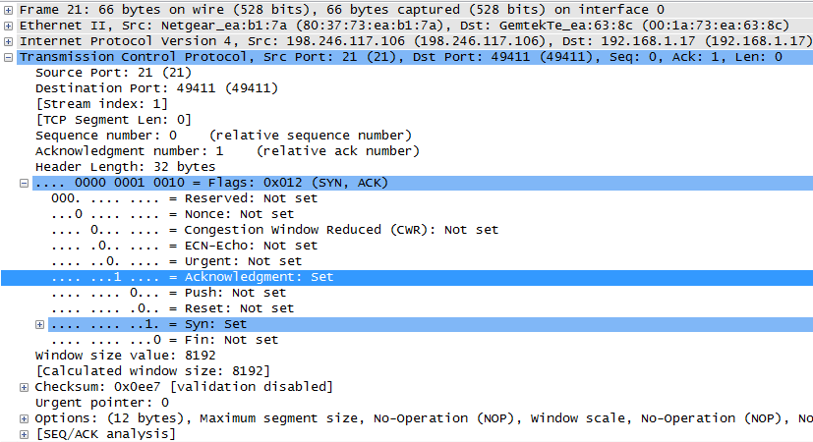

Fill in the following information regarding the SYN-ACK message.

| Description | Wireshark Results |
| --- | --- |
| Source IP address | blank |
| Destination IP address | blank |
| Source port number | blank |
| Destination port number | blank |
| Sequence number | blank |
| Acknowledgment number | blank |
| Header length | blank |
| Window size | blank |

In the final stage of the negotiation to establish communications, the VM sends an acknowledgment message to the server. Notice that only the ACK bit is set to 1, and the Sequence number has been incremented to 1.

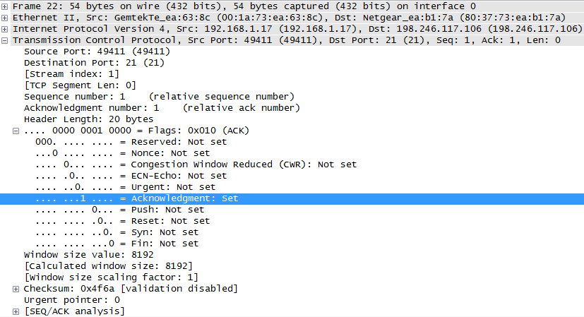

Fill in the following information regarding the ACK message.

| Description | Wireshark Results |
| --- | --- |
| Source IP address | blank |
| Destination IP address | blank |
| Source port number | blank |
| Destination port number | blank |
| Sequence number | blank |
| Acknowledgment number | blank |
| Header length | blank |
| Window size | blank |

#### Question:

How many other TCP datagrams contained a SYN bit?

Type your answers here.

After a TCP session is established, FTP traffic can occur between the PC and FTP server. The FTP client and server communicate with each other, unaware that TCP has control and management over the session. When the FTP server sends a *Response: 220* to the FTP client, the TCP session on the FTP client sends an acknowledgment to the TCP session on the server. This sequence is visible in the Wireshark capture below.

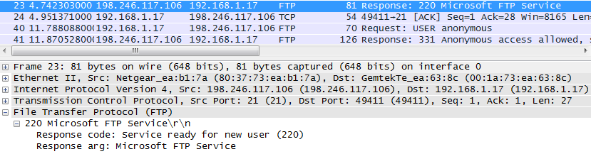

When the FTP session has finished, the FTP client sends a command to “quit”. The FTP server acknowledges the FTP termination with a *Response: 221 Goodbye*. At this time, the FTP server TCP session sends a TCP datagram to the FTP client, announcing the termination of the TCP session. The FTP client TCP session acknowledges receipt of the termination datagram, then sends its own TCP session termination. When the originator of the TCP termination (the FTP server) receives a duplicate termination, an ACK datagram is sent to acknowledge the termination and the TCP session is closed. This sequence is visible in the diagram and capture below.

A diagram showing the FTP and TCP termination steps

By applying an **ftp** filter, the entire sequence of the FTP traffic can be examined in Wireshark. Notice the sequence of the events during this FTP session. The username **anonymous** was used to retrieve the Readme file. After the file transfer completed, the user ended the FTP session.

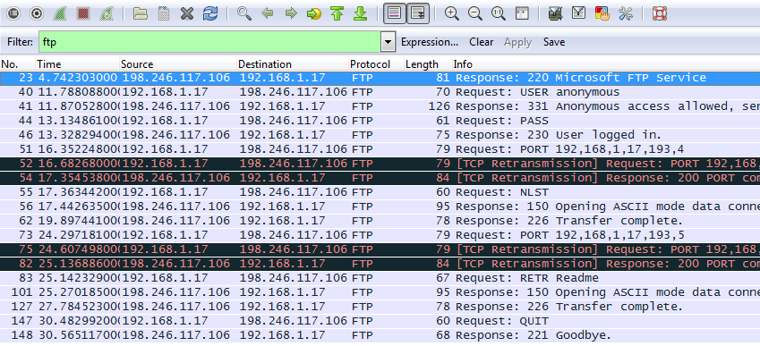

Apply the TCP filter again in Wireshark to examine the termination of the TCP session. Four packets are transmitted for the termination of the TCP session. Because TCP connection is full duplex, each direction must terminate independently. Examine the source and destination addresses.

In this example, the FTP server has no more data to send in the stream. It sends a segment with the FIN flag set in frame 149. The PC sends an ACK to acknowledge the receipt of the FIN to terminate the session from the server to the client in frame 150.

In frame 151, the PC sends a FIN to the FTP server to terminate the TCP session. The FTP server responds with an ACK to acknowledge the FIN from the PC in frame 152. Now the TCP session is terminated between the FTP server and PC.

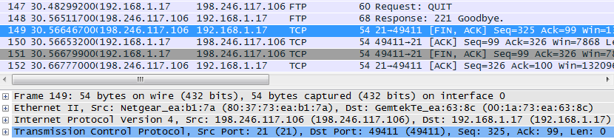

## Identify UDP Header Fields and Operation Using a Wireshark TFTP Session Capture

In Part 2, you use Wireshark to capture a TFTP session and inspect the UDP header fields.

### Start Mininet and tftpd service.

* + - 1. Start Mininet. Enter **cyberops** as the password when prompted.

[analyst@secOps ~]$ **sudo lab.support.files/scripts/cyberops_topo.py**

[sudo] password for analyst:

* + - 1. Start H1 and H2 at the **mininet>** prompt.

*** Starting CLI:

mininet> **xterm H1 H2**

* + - 1. In the **H1** terminal window, start the tftpd server using the provided script.

[root@secOps analyst]# **/home/analyst/lab.support.files/scripts/start_tftpd.sh**

[root@secOps analyst]#

### Create a file for tftp transfer.

* + - 1. Create a text file at the **H1** terminal prompt in the /srv/tftp/ folder.

[root@secOps analyst]# **echo "This file contains my tftp data." > /srv/tftp/my_tftp_data**

* + - 1. Verify that the file has been created with the desired data in the folder.

[root@secOps analyst]# **cat /srv/tftp/my_tftp_data**

This file contains my tftp data.

* + - 1. Because of the security measure for this particular tftp server, the name of the receiving file needs to exist already. On **H2**, create a file named **my_tftp_data**.

[root@secOps analyst]# **touch my_tftp_data**

### Capture a TFTP session in Wireshark

* + - 1. Start Wireshark in **H1**.

[root@secOps analyst]# **wireshark &**

* + - 1. From the **Edit** menu, choose **Preferences** andclick the arrow to expand **Protocols**. Scroll down and select **UDP**. Click the **Validate the UDP checksum if possible** check box and click **OK**.

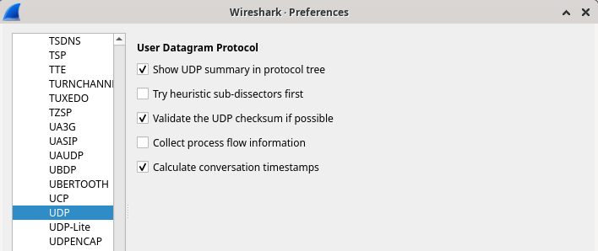

* + - 1. Start a Wireshark capture on the interface **H1-eth0**.
      2. Start a tftp session from **H2** to the tftp server on **H1** and get the file **my_tftp_data**.

[root@secOps analyst]# **tftp 10.0.0.11 -c get my_tftp_data**

* + - 1. Stop the Wireshark capture. Set the filter to **tftp** and click **Apply**. Use the three TFTP packets to fill in the table and answer the questions in the rest of this lab.

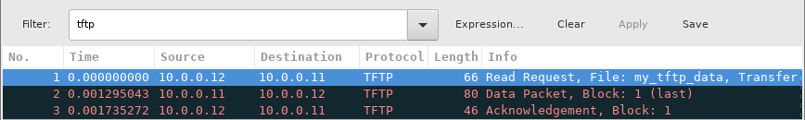

Detailed UDP information is available in the Wireshark packet details pane. Highlight the first UDP datagram from the host computer and move the mouse pointer to the packet details pane. It may be necessary to adjust the packet details pane and expand the UDP record by clicking the protocol expand box. The expanded UDP datagram should look similar to the diagram below.

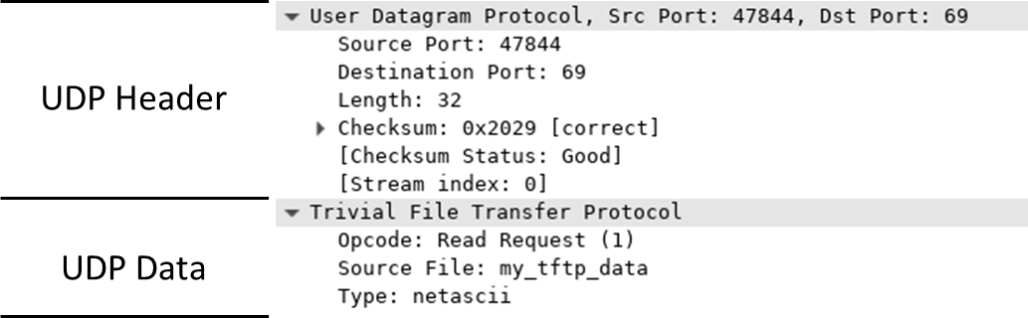

The figure below is a UDP datagram diagram. Header information is sparse, compared to the TCP datagram. Similar to TCP, each UDP datagram is identified by the UDP source port and UDP destination port.

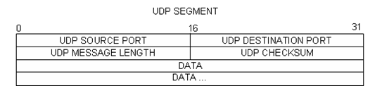

Using the Wireshark capture of the first UDP datagram, fill in information about the UDP header. The checksum value is a hexadecimal (base 16) value, denoted by the preceding 0x code:

| Description | Wireshark Results |
| --- | --- |
| Source IP address | blank |
| Destination IP address | blank |
| Source port number | blank |
| Destination port number | blank |
| UDP message length | blank |
| UDP checksum | blank |

#### Question:

How does UDP verify datagram integrity?

Type your answers here.

Examine the first frame returned from the tftpd server. Fill in the information about the UDP header:

| Description | Wireshark Results |
| --- | --- |
| Source IP address | blank |
| Destination IP address | blank |
| Source port number | blank |
| Destination port number | blank |
| UDP message length | blank |
| UDP checksum | blank |

Notice that the return UDP datagram has a different UDP source port, but this source port is used for the remainder of the TFTP transfer. Because there is no reliable connection, only the original source port used to begin the TFTP session is used to maintain the TFTP transfer.

Also, notice that the UDP Checksum is incorrect. This is most likely caused by UDP checksum offload. You can learn more about why this happens by searching for “UDP checksum offload”.

### Clean up

In this step, you will shut down and clean up Mininet.

* + - 1. In the terminal that started Mininet, enter **quit** at the prompt.

mininet> **quit**

* + - 1. At the prompt, enter **sudo mn –c** to clean up the processes started by Mininet.

[analyst@secOps ~]$ **sudo mn -c**

# Reflection Question

This lab provided the opportunity to analyze TCP and UDP protocol operations from captured FTP and TFTP sessions. How does TCP manage communication differently than UDP?

Type your answers here.

End of document